Scheduling fingerprinting requirement for clinical rotations at Kootenai Behavioral Health
(Student Procedure)

Some students placed in Kootenai Health’s Adult and Youth Acute Behavioral Health departments, Chemical Dependency, or the Crisis Center may have to complete an Idaho Health and Welfare Fingerprinted Criminal Background Check. Idaho requires that anyone (including students) spending time with these at risk patient populations complete this requirement prior to beginning time at these facilities. This process can take 4-5 weeks for the state of Idaho to process.

Review the descriptions below to determine if you/your students require an Idaho Health and Welfare Fingerprinted Criminal Background Check.
- Chemical Dependency: Idaho Health and Welfare Fingerprinted Criminal Background Check required
- Crisis Center: Idaho Health and Welfare Fingerprinted Criminal Background Check required
- Adult Behavioral Health: Idaho State Police background check accepted
- Idaho Health and Welfare Fingerprinted Criminal Background Check required for Senior Practicum experiences or placement >100 hours
- Youth Acute Behavioral Health: Idaho State Police background check accepted
- Idaho Health and Welfare Fingerprinted Criminal Background Check required for Senior Practicum experiences or placement >100 hours

The steps below will help walk you through the process of registering to be fingerprinted and knowing what documents to give back to your collegiate program administrator.

Things you will need to complete this process
Your driver’s license
A computer with an internet connection
An ‘Employer Number’ – 7052
Payment (See current cost on https://chu.dhw.idaho.gov site)

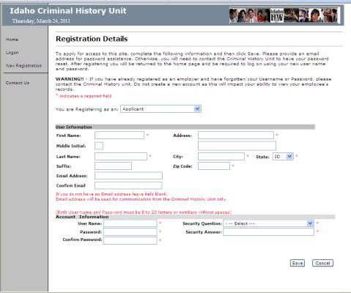
To create an account
Go to: https://chu.dhw.idaho.gov
Choose: New Registration (on left hand menu) Register as: Applicant
Complete User Information and Account Information sections Complete Account Information
User Name and Password are case sensitive Write them down. You will need them again. Click ‘Save’

To log on and register for fingerprinting
Go to: https://chu.dhw.idaho.gov Choose: Logon (on left hand menu) Enter user name and password
Click ‘Logon’. (Do not log on as an employer) Select ‘Complete Application’ (on left hand menu)
Complete Personal Information Click ‘Next’ (not ‘Save and Close’

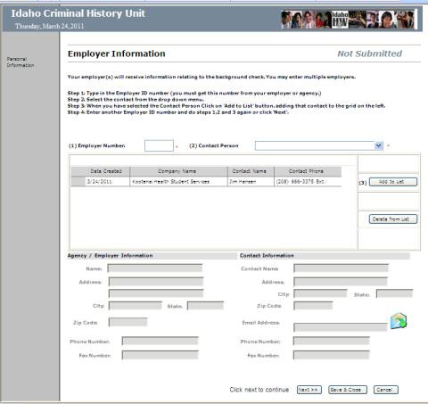
Employer Information Page
Enter Employer Number in box 1
Name of contact person will come up in box 2 Click on: Add to List (box 3)
Click on Next (not ‘Save and Close’)

Types of Services page
- Click the box for one of the following Service types that best fits your clinical rotation
- Behavioral Health Programs,
- Children’s Mental Health Services Providers,
or
- Behavioral Health Community Crisis Centers
- Click ‘Next’

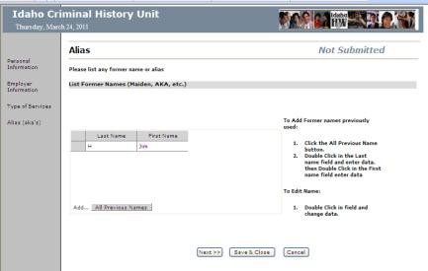
Alias page
If you have any other names (like a maiden or AKA name) follow the directions at the right of the screen, then click ‘Next’
If you have no other names, then just click ‘Next’

Criminal Record, Outstanding Warrants, Child Protection Involvement, Adult Protection Involvement, Medicare/Medicaid Exclusion, Driver’s License Information pages
Answer all questions by clicking ‘yes’ or ‘no’ Click ‘Submit’

Schedule Finger Printing
Note: You have 30 days from the date you submitted your application, or your application will be inactivated
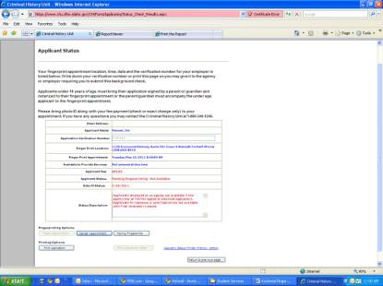
Click on ‘Schedule Finger Print Appointment’
Select ‘Coeur d’Alene’ from the drop down menu (Step 1) Click on a convenient date in red for you to be in Coeur d’Alene (Step 2)
Click: on a convenient time for you to be fingerprinted at the Coeur d’Alene office (Step 3)
Note that your chosen date/time is highlighted in red at the bottom of the screen (Step 4)
Click ‘Save’

Printing and notarizing your application
Print a personal copy of the scheduled appointment
Click the browser print button. Keep this reminder of your appointment time and address of Health & Welfare

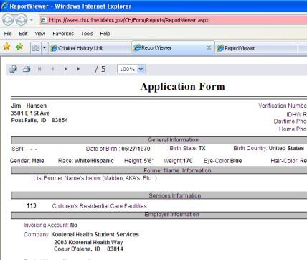
Print the full application for notarization and keeping at the school Click ‘Print Application’
Do not click the browser print button. Click the printer icon embedded in the screen
Another page will come up. Select ‘All’ pages in the page range, and click ‘OK’
Do not click the browser print button. Click the printer icon embedded in the screen
Click ‘OK’. 5 pages should print

Notarizing the application
Page 5 of the printed application has a section for you to sign in the presence of a Notary.
- Application
- Valid ID
- Once the application is signed and notarized, return one copy to your program administrator, and the original to KH Organizational Development Office.
- Students must take a copy of notarized application to fingerprinting appointment.

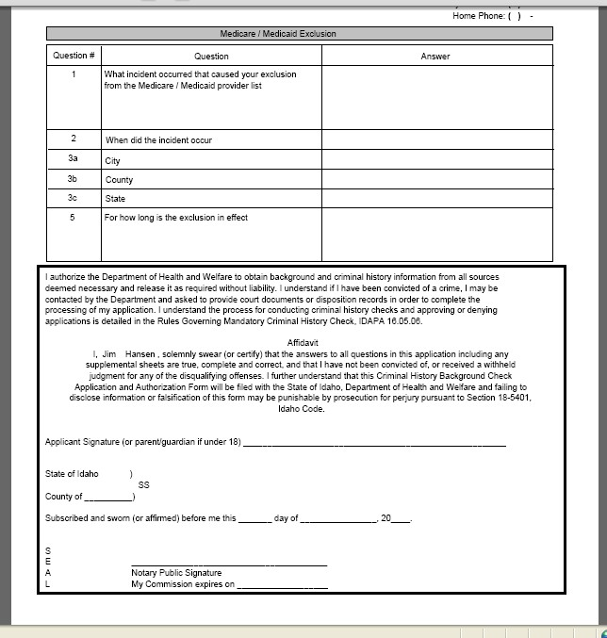

Submitting Fingerprints by Mail
- When an individual elects to have fingerprints collected by a local law enforcement agency (out of state students) or by the applicant’s employer, the Idaho Department’s fingerprint card must be used.
- Please contact the Criminal History Unit at 1-800-340-1246 or e-mail at crimhist@dhw.idaho.gov to request your application package. The fingerprint card must be completed in accordance with the instructions provided in this packet, signed and mailed along with the completed, notarized application and applicable fee to the address indicated on the Department’s Mail-in Instructions.
- This may add an additional week to completion and processing.

Previous Fingerprint Clearance Transfer

If an individual has previously completed a fingerprint and background check, within the last 3 years of the completion date, that information is transferable to other agencies, such as Kootenai Health. To transfer this information for Kootenai’s records the individual must complete the following steps.

E-mail crimhist@dhw.idaho.gov with the following request and information.

I, ___________________ (full name including middle initial) am requesting a transfer of my fingerprint based criminal history background check information to be accessible by Kootenai Health Student Services Department. (Employer ID # 7052). My date of birth is ______________.

To complete this transfer of information the student must also complete the Name Based Criminal Background Check Form.

To complete the form

Go to: https://chu.dhw.idaho.gov
Choose the: Idaho State Records Checks tab
Complete: Idaho State Police-Criminal History Request Form
Cost: $20.00
- Once you receive notification that your information has been transferred please notify Kootenai Student Services at: studentservices@kh.org

General Information
- Idaho Criminal Background Checks and Fingerprinting are acceptable for 3 years.
- Begin this process four-five weeks prior to clinical rotation. Add an additional week if mailing in fingerprints.

